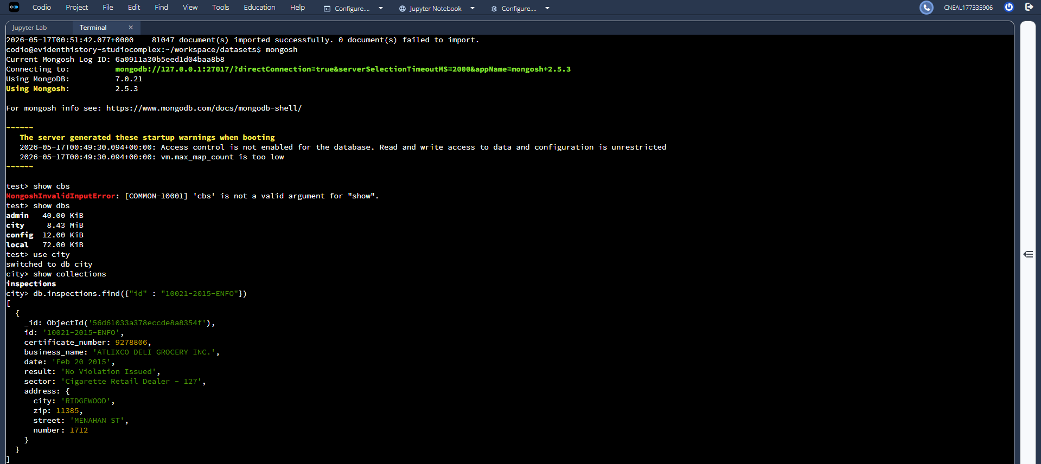
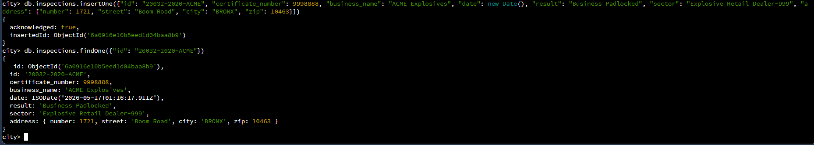
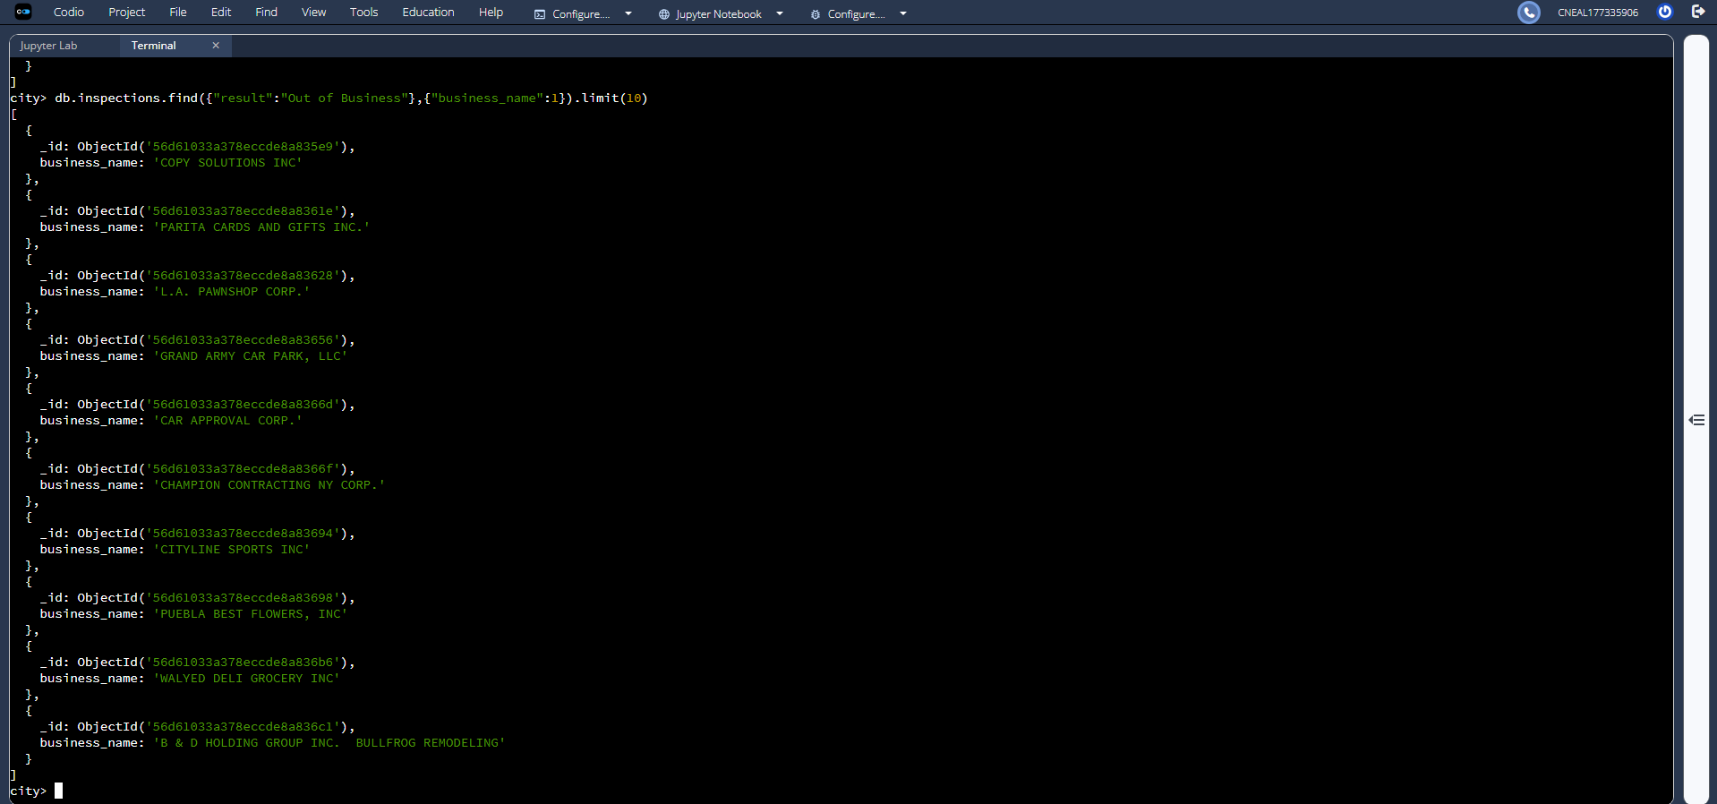
There are 87 distinct sectors.
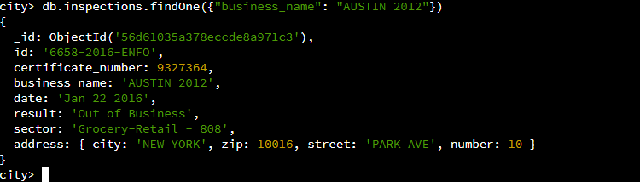
Austin 2012’s date appears hand typed rather than generated via Date(). Further, it lacks the time element.
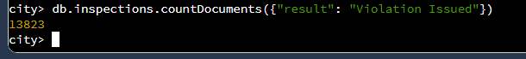
13,823 businesses have had violations issued.
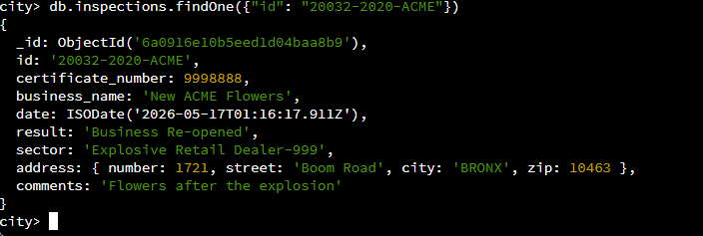

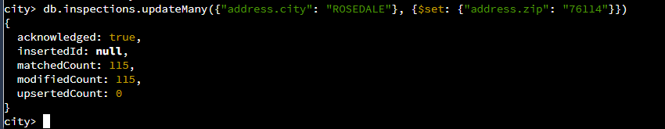
First two results before deletion:
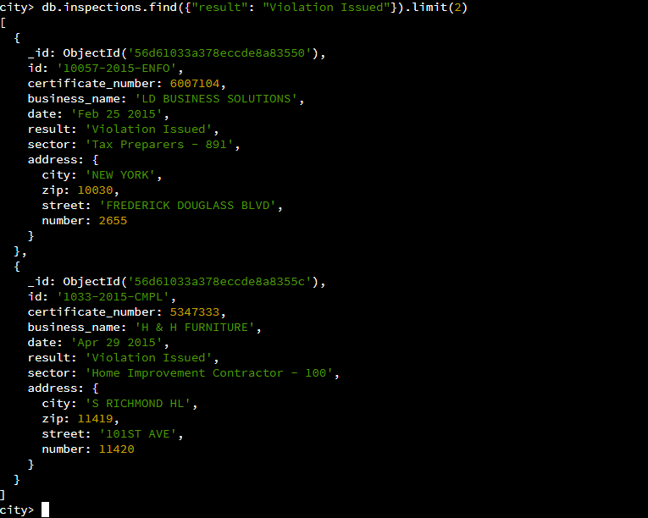

Delete command and confirmation of LD Business Solutions’ removal:
